MULTISITE GRANT MANAGEMENT SYSTEM

Account head wise allocation

User Guide Document

Ver. 1.4

Version History
Date | Description
26-Oct-2010 | First draft

Table of Contents

Version History 2
1 Introduction 4
1.1 Purpose 4
2 Disburse fund against account heads 4

Introduction

Purpose

This document provides the step-by-step instructions for account head-wise allotment within the institution, of the allocated amount for the project as per the grant, through the Multisite Grant Management System.

Please note that this is a ‘living document’ and the specification will change, continuously, as the project proceeds. More details will be added and the existing information edited as the requirements, scenarios and use cases evolve in the course of the project.

Disburse fund against account heads

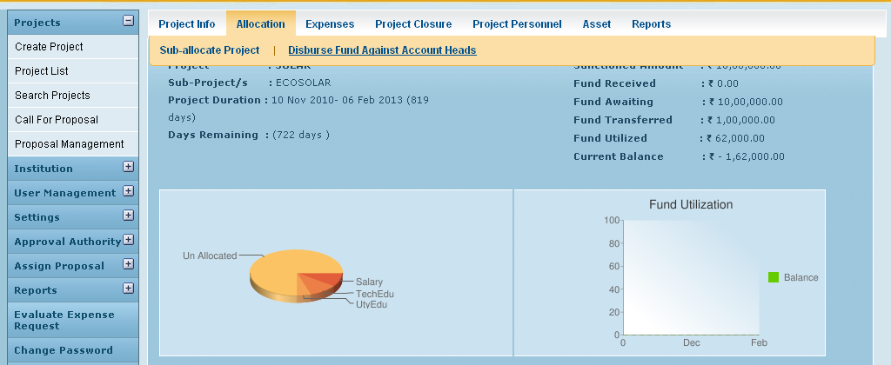
Do Head wise Allocation

Click on Disburse fund against account heads to do the head wise allocation.

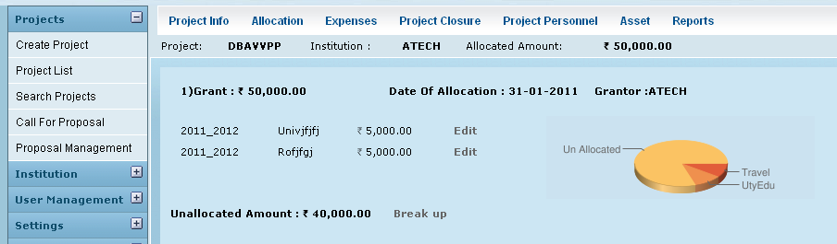
Click on Break up Link

Enter the details and click on Create to do the allocation
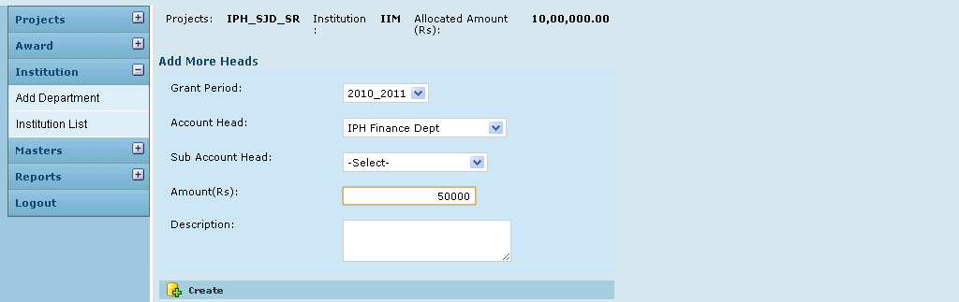
Click on Create to complete the allocation

List of Head wise Allocation shown on the page.
Click on Edit to do modifications for each entry (if any).

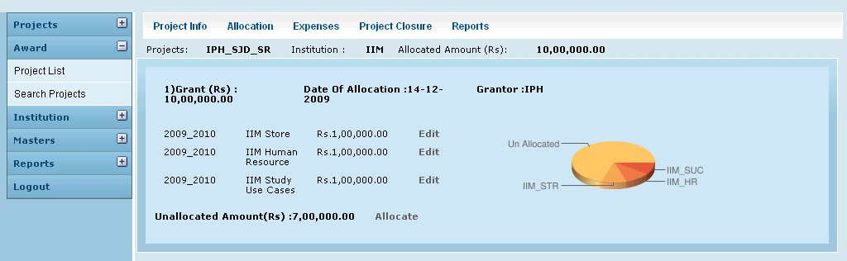
Click on Edit link to modify allocations

